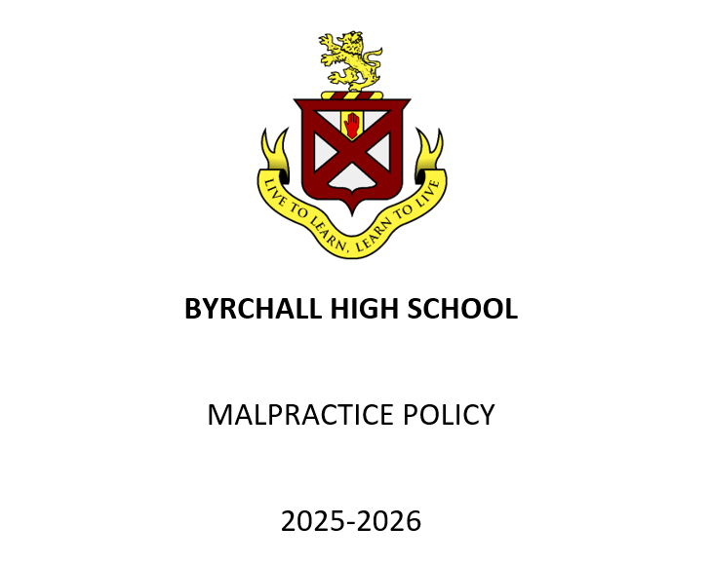

MALPRACTICE POLICY 2024/25

Centre name | Byrchall High School
Centre number | 33701
Date policy first created | 01/07/2024
Current policy approved by | Cheryl Smith
Current policy reviewed by | Joanne Finn
Date of next review | 17/11/2026

Key staff involved in the policy

Role | Name
Head of centre | Phil Paul
Senior leader(s) | Anita Hudson  Cheryl Smith  Tracey Wilkinson  Cathie Lipton  Katrina Millward  Jack Thirlby  Dale Tudor
Exams officer | Joanne Finn
Other staff (if applicable) | Melissa Caroll

This policy is reviewed and updated annually to ensure that any malpractice at Byrchall High School is managed in accordance with current requirements and regulations.
Reference in the policy to GR and SMPP relate to relevant sections of the current JCQ publications General Regulations for Approved Centres and Suspected Malpractice: Policies and Procedures.

Introduction
What is malpractice and maladministration?
‘Malpractice’ and ‘maladministration’ are related concepts, the common theme of which is that they involve a failure to follow the rules of an examination or assessment. This policy and procedure uses the word ‘malpractice’ to cover both ‘malpractice’ and ‘maladministration’ and it means any act, default or practice which is:
- a breach of the Regulations
- a breach of awarding body requirements regarding how a qualification should be delivered
- a failure to follow established procedures in relation to a qualification which:
- gives rise to prejudice to candidates
- compromises public confidence in qualifications
- compromises, attempts to compromise or may compromise the process of assessment, the integrity of any qualification or the validity of a result or certificate
- damages the authority, reputation or credibility of any awarding body or centre or any officer, employee or agent of any awarding body or centre (SMPP 1)
Candidate malpractice
‘Candidate malpractice’ means malpractice by a candidate in connection with any examination or assessment, including the preparation and authentication of any controlled assessments, coursework or non-examination assessments, the presentation of any practical work, the compilation of portfolios of assessment evidence and the writing of any examination paper. (SMPP 2)
Centre staff malpractice
'Centre staff malpractice’ means malpractice committed by:
- a member of staff, contractor (whether employed under a contract of employment or a contract for services) or a volunteer at a centre; or
- an individual appointed in another capacity by a centre such as an invigilator, a Communication Professional, a Language Modifier, a practical assistant, a prompter, a reader or a scribe (SMPP 2)
Suspected malpractice
For the purposes of this document, suspected malpractice means all alleged or suspected incidents of malpractice. (SMPP 2)

Purpose of the policy
To confirm Byrchall High School:
- has in place a written malpractice policy which covers all qualifications delivered by the centre and details how candidates are informed and advised to avoid committing malpractice in examinations/assessments, how suspected malpractice issues should be escalated within the centre and reported to the relevant awarding body (GR 5.3)

General principles
In accordance with the regulations Byrchall High School will:
- Take all reasonable steps to prevent the occurrence of any malpractice (which includes maladministration) before, during and after examinations have taken place (GR 5.11)
- Inform the awarding body immediately of any alleged, suspected or actual incidents of malpractice or maladministration, involving a candidate or a member of staff, by completing the appropriate documentation (GR 5.11)
- As required by an awarding body, gather evidence of any instances of alleged or suspected malpractice (which includes maladministration) in accordance with the JCQ publication Suspected Malpractice - Policies and Procedures and provide such information and advice as the awarding body may reasonably require (GR 5.11)

Preventing malpractice
Byrchall High School has in place:
- Robust processes to prevent and identify malpractice, as outlined in section 3 of the JCQ publication Suspected Malpractice: Policies and Procedures. (SMPP 4.3)
- This includes ensuring that all staff involved in the delivery of assessments and examinations understand the requirements for conducting these as specified in the following JCQ documents and any further awarding body guidance: General Regulations for Approved Centres 2025-2026; Instructions for conducting examinations (ICE) 2025-2026; Instructions for conducting coursework 2025-2026; Instructions for conducting non-examination assessments 2025-2026; Access Arrangements and Reasonable Adjustments 2025-2026; A guide to the special consideration process 2025-2026; Suspected Malpractice: Policies and Procedures 2025- 2026; Plagiarism in Assessments; AI Use in Assessments: Protecting the Integrity of Qualifications; A guide to the awarding bodies’ appeals processes 2025-2026 (SMPP 3.3.1)
Informing and advising candidates how to avoid committing malpractice in examinations/assessments
Candidates are advised on how to avoid committing malpractice during assemblies delivered by SLT and in their exam procedures booklets that they receive prior to exams. They are also informed prior to the start of every exam and exam notices are displayed outside every exam room.
AI Use in Assessments
Students complete the majority of their exams and a large number of other assessments under close staff supervision with limited access to authorised materials and no permitted access to the internet. The delivery of these assessments should be unaffected by developments in AI tools as students must not be able to use such tools when completing these assessments.

There are some assessments in which access to the internet is permitted in the preparatory, research or production stages. The majority of these assessments will be Non-Examined Assessments (NEAs), coursework and internal assessments for General Qualifications (GQs) and Vocational & Technical Qualifications (VTQs).
JCQ’s guidance which is designed to help students and teachers to complete NEAs, coursework and other internal assessments successfully is followed in relation to these assessments.

The following JCQ support resources will also be used to help teachers understand and prevent AI misuse and to help students to better understand the rules for use of AI in assessments: Information Sheet for Teachers, Senior Leader Presentation for Teachers, Poster for Students, Teacher Presentation for Students.

Identification and reporting of malpractice
Escalating suspected malpractice issues
- Once suspected malpractice is identified, any member of staff at the centre can report it using the appropriate channels (SMPP 4.3)
Suspected malpractice is recorded on the exam incident log and/or reported directly to the EO. The EO consults with SLT with regards to the steps taken to deal with the suspected malpractice. The relevant reports to the exam boards are then completed and emailed.
Reporting suspected malpractice to the awarding body
- The head of centre will notify the appropriate awarding body immediately of all alleged, suspected or actual incidents of malpractice, using the appropriate forms, and will conduct any investigation and gathering of information in accordance with the requirements of the JCQ publication Suspected Malpractice: Policies and Procedures (SMPP 4.1.3)
- The head of centre will ensure that where a candidate who is a child/vulnerable adult is the subject of a malpractice investigation, the candidate’s parent/carer/ appropriate adult is kept informed of the progress of the investigation (SMPP 4.1.3)
- Form JCQ/M1 will be used to notify an awarding body of an incident of candidate malpractice. Form JCQ/M2 will be used to notify an awarding body of an incident of suspected staff malpractice/maladministration (SMPP 4.4, 4.6)
- Malpractice by a candidate discovered in a controlled assessment, coursework or non- examination assessment component prior to the candidate signing the declaration of authentication need not be reported to the awarding body but will be dealt with in accordance with the centre’s internal procedures. The only exception to this is where the awarding body’s confidential assessment material has potentially been breached. The breach will be reported to the awarding body immediately (SMPP 4.5)
- If, in the view of the investigator, there is sufficient evidence to implicate an individual in malpractice, that individual (a candidate or a member of staff) will be informed of the rights of accused individuals (SMPP 5.33)
- Once the information gathering has concluded, the head of centre (or other appointed information- gatherer) will submit a written report summarising the information obtained and actions taken to the relevant awarding body, accompanied by the information obtained during the course of their enquiries (5.35)
- Form JCQ/M1 will be used when reporting candidate cases; for centre staff, form JCQ/M3 will be used (SMPP 5.37)
- The awarding body will decide on the basis of the report, and any supporting documentation, whether there is evidence of malpractice and if any further investigation is required. The head of centre will be informed accordingly (SMPP 5.40)

Communicating malpractice decisions
Once a decision has been made, it will be communicated in writing to the head of centre as soon as possible. The head of centre will communicate the decision to the individuals concerned and pass on details of any sanctions and action in cases where this is indicated. The head of centre will also inform the individuals if they have the right to appeal. (SMPP 11.1)

Appeals against decisions made in cases of malpractice
Byrchall High School will:
- Provide the individual with information on the process and timeframe for submitting an appeal, where relevant
- Refer to further information and follow the process provided in the JCQ publication A guide to the awarding bodies' appeals processes

Changes 2024/2025
Under heading Purpose of the policy: (Changed) The purpose of this policy is to confirm how Byrchall High School manages malpractice under normal delivery arrangements in accordance with the regulations. (To) To confirm Byrchall High School has in place a written malpractice policy which covers all qualifications delivered by the centre and details how candidates are informed and advised to avoid committing malpractice in examinations/assessments, how suspected malpractice issues should be escalated within the centre and reported to the relevant awarding body (GR 5.3)
Under heading General Principles: Moved subsections Candidate malpractice and Centre staff malpractice
from this section and added under Introduction section
Under heading Preventing Malpractice: (Added) A new bullet point: This includes ensuring that all staff involved in the delivery of assessments and examinations understand the requirements for conducting these as specified in the following JCQ documents and any further awarding body guidance:
- General Regulations for Approved Centres 2025-2026
- Instructions for conducting examinations (ICE) 2025-2026
- Instructions for conducting coursework 2025 - 2026
- Instructions for conducting non-examination assessments 2025-2026
- Access Arrangements and Reasonable Adjustments 2025-2026
- A guide to the special consideration process 2025-2026
- Suspected Malpractice: Policies and Procedures 2025-2026
- Plagiarism in Assessments
- AI Use in Assessments: Protecting the Integrity of Qualifications
- A guide to the awarding bodies’ appeals processes 2025-2026 (SMPP 3.3.1)
(Added) New subheading Informing and advising candidates and an insert field to be populated according to the centre’s process
Under heading Identification and reporting of malpractice: (Added) New subheading Escalating suspected malpractice issues and
- new bullet point: Once suspected malpractice is identified, any member of staff at the centre can report it using the appropriate channels (SMPP 4.3)
- an insert field to be populated according to the centre’s process
(Added) New subheading Reporting suspected malpractice to the awarding body
(Added) New bullet point: The head of centre will ensure that where a candidate who is a child/vulnerable adult is the subject of a malpractice investigation, the candidate’s parent/carer/ appropriate adult is kept informed of the progress of the investigation (SMPP 4.1.3)
(Changed) SMPP reference: If, in the view of the investigator, there is sufficient evidence to implicate an individual in malpractice, that individual (a candidate or a member of staff) will be informed of the rights of accused individuals (SMPP 5.32) (To) If, in the view of the investigator, there is sufficient evidence to implicate an individual in malpractice, that individual (a candidate or a member of staff) will be informed of the rights of accused individuals (SMPP 5.33)
(Changed) Once the information gathering has concluded, the head of centre (or other appointed information-gatherer) will submit a written report summarising the case to the relevant awarding body, accompanied by the information obtained during the course of their enquiries (SMPP 5.34) (To) Once the information gathering has concluded, the head of centre (or other appointed information-gatherer) will submit a written report summarising the information obtained and actions taken to the relevant awarding body, accompanied by the information obtained during the course of their enquiries (SMPP 5.35)
(Changed) SMPP reference: Form JCQ/M1 will be used when reporting candidate cases; for centre staff, form JCQ/M3 will be used (SMPP 5.36) (To) Form JCQ/M1 will be used when reporting candidate cases; for centre staff, form JCQ/M3 will be used (SMPP 5.37)
(Changed) SMPP reference: The awarding body will decide on the basis of the report, and any supporting documentation, whether there is evidence of malpractice and if any further investigation is required. The head of centre will be informed accordingly (SMPP 5.39) (To) The awarding body will decide on the basis of the report, and any supporting documentation, whether there is evidence of malpractice and if any further investigation is required. The head of centre will be informed accordingly (SMPP 5.40)
Under heading Appeals against decisions made in cases of malpractice:(Changed) Provide the individual with information on the process for submitting an appeal, where relevant (To) Provide the individual with information on the process and timeframe for submitting an appeal, where relevant

