Mathematics
Mathematics: working hard together, achieving together, making every lesson count
The Mathematics Team will provide students with exciting, relevant and challenging Mathematics, delivered by dedicated staff. Students will understand the underlying principles of the mathematics they learn, making links and developing reasoning skills and logical thinking. They will progress towards being independent mathematicians who take ownership of their learning and can identify correct and incorrect work for themselves. Students will have their confidence encouraged and their complacency challenged in order to maximise potential.
To achieve this, staff will design and develop simple and effective systems and interesting and effective teaching ideas and resources to enable classroom delivery and promote mathematics across the school.

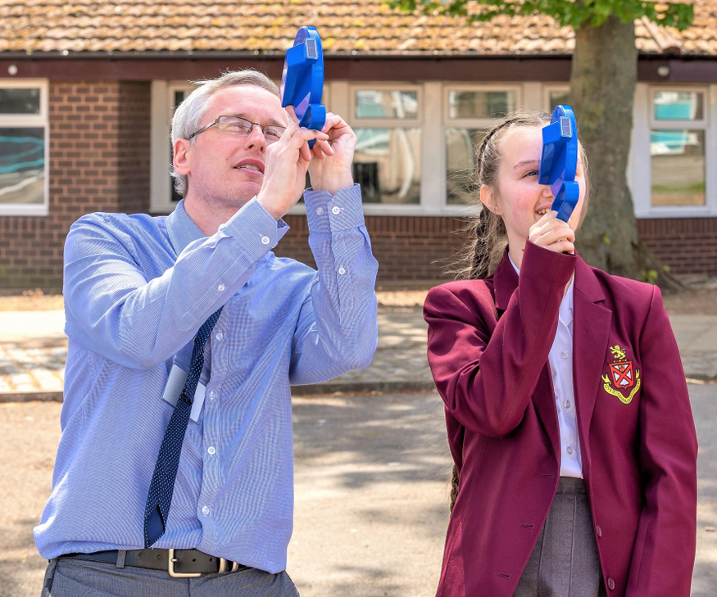

Autumn |  | Spring |  | Summer
Recurring decimals Surds Quadratics: graphing, solving, sequences | Compound Measures Transformations Scale Drawing Constructions Loci | Personalised Mock Exam Preparation Pythagoras’ Theorem Basic Trigonometry | Simultaneous Equations Linear Inequalities | Advanced Trigonometry Proportionality Properties of 2D shapes Circle Theorems | P,A,V  Bounds

Students will receive one piece of homework per week via our new online platform “Sparx Maths”. The piece of work will be designed to last around 1 hour. Though the answers are submitted online, students will be expected to complete homework in their books and show all working out. Regular book checks will be performed by their class teacher.

In Year 10 your child will continue their GCSE studies on either the Foundation or Higher pathway. Again, there is a flexible approach should the need arise for a change in pathway.

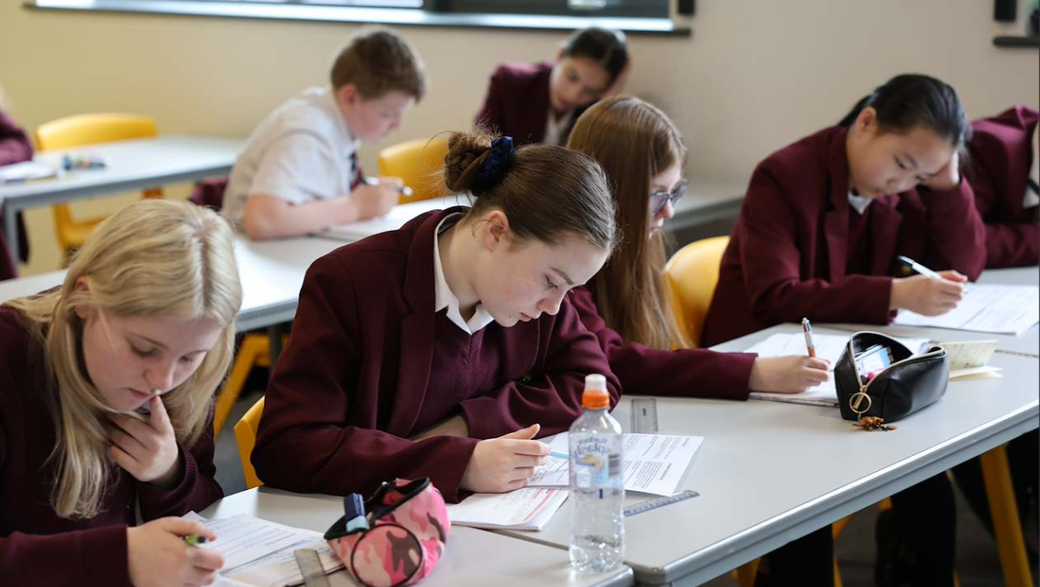
Higher
Unit | Duration (WEEKS) | Learning Objectives/Outcomes
Real Life Graphs | 2 | - To draw and interpret straight line graphs for real-life situations.  - To draw and interpret distance-time graphs.
Recurring Decimals | 1 | - To convert between recurring decimals and fractions.  - To understand a recurring decimal to fraction proof.
Surds | 1 | - To use surds and π in exact calculations, without a calculator.  - To manipulate with surds.  - To rationalise a denominator.
Quadratics | 4 | - To plot and sketch a quadratic function.  - To use quadratic functions to find approximate solutions of quadratic equations.  - To solve a quadratic equation across a variety of methods.  - To recognise, extend and describe quadratic sequences.
Scales, Measures, & Compound Measures | 2 | - To interpret a range of scales and units.  - To make sensible estimates and choose appropriate units.  - To convert to and from a range of imperial and metric measures.  - To recognise the inaccuracy of measurements and rounding errors.  - To understand and use compound measures, including units.
Standard Form | 2 | - To convert to and from standard form.  - To calculate with standard form.  - To use calculators efficiently for standard form problems.
Transformations | 2 | - To be able to describe and perform transformations.
Scale Drawing, Maps, & Bearings | 1 | - To interpret and construct a scale drawing.  - To draw and describe bearings.

Constructions & Loci | 2 | - To make accurate constructions.  - To find and describe regions satisfying a combination of loci.
Pythagoras’ Theorem | 2 | - To understand, recall and use Pythagoras’ theorem in 2- D, then in 3-D problems.  - To understand the language of planes, and recognise the diagonals of a cuboid.
Simple Trigonometry | 1 | - To understand, recall and use trigonometric relationships in right-angled triangles.  - To use basic trigonometry to solve problems in 2D and 3D.
Simultaneous Equations | 3 | - To solve linear simultaneous equations using a variety of methods.  - To solve nonlinear simultaneous equations.  - To find approximate solutions to simultaneous equations using a graphical approach.
Linear Inequalities | 1 | - To solve inequalities and represent solutions on a number line  - To use the correct notation in inequalities, graphs, and number lines.  - To show the solution set of several inequalities in two variables on a graph.
Advanced Trigonometry | 2 | - To use sine and cosine rule to solve problems in 2D and 3D.  - To use advanced trigonometry to find the area of a triangle.
Proportionality | 2 | - To calculate an unknown quantity from quantities that vary in direct or inverse proportion.  - To solve problems using proportionality.
Circle Theorems | 2 | - To know and use circle theorems to calculate angles and solve problems.  - To know the proof of selected circle theorems.
Perimeter, Area, & Volume | 3 | - To know the properties and names of quadrilaterals and other polygons.  - To solve problems involving more complex shapes and 3D solids.  - To find the surface area and volumes of compound solids.  - To solve problems using algebraic notation.

Upper & Lower Bounds | 1 | - To calculate upper and lower bounds working with measurements.  - To solve problems, involving geometry and measure, using upper and lower bounds.

Foundation
Unit | Duration (WEEKS) | Learning Objectives/Outcomes
Straight Line & Real Life Graphs | 2 | - To draw and interpret straight line graphs for real-life situations.  - To draw and interpret distance-time graphs.
Recurring Decimals | 1 | - To identify fractions that convert to terminating and recurring decimals.  - To convert between recurring decimals and fractions.
Sequences | 2 | - To recognise and extend sequences.  - To generate sequences from nth terms and diagrams.  - To find and use the nth term of an arithmetic sequence.
Quadratics | 3 | - To plot and sketch a quadratic function.  - To use quadratic functions to find approximate solutions of quadratic equations.  - To factorise and solve a quadratic equation.
Scales, Measures, & Compound Measures | 2 | - To interpret a range of scales and units.  - To make sensible estimates and choose appropriate units.  - To convert to and from a range of imperial and metric measures.  - To recognise the inaccuracy of measurements and rounding errors.  - To understand and use compound measures, including units.
Standard Form | 2 | - To convert to and from standard form.  - To calculate with standard form.  - To use calculators efficiently for standard form problems.
Transformations | 3 | - To be able to describe and perform transformations.
Scale Drawing & Maps & Bearings | 2 | - To interpret and construct a scale drawing.  - To draw and describe bearings.
Constructions & | 4 | - To make accurate constructions.

Loci |  | - To find and describe regions satisfying a combination of loci.
Pythagoras’ Theorem | 2 | - To understand, recall and use Pythagoras’ theorem in 2- D.
Simultaneous Equations | 2 | - To solve linear simultaneous equations using a variety of methods.  - To find approximate solutions to simultaneous equations using a graphical approach.
Quadrilaterals & Symmetry | 2 | - To recall the name, properties and definitions of a variety of  quadrilaterals.
Formula | 1 | - To derive and substitute into a formula including those with indices.
Co-ordinates | 2 | - To identify points with given coordinates, and coordinates of given points, in all four quadrants in 2-D.  - To find the coordinates of the midpoint of a line segment.  - To calculate the length of a line segment.
Complex Curves | 2 | - To recognise and draw the graph of a cubic and a reciprocal.
Linear Inequalities | 1 | - To solve inequalities and represent solutions on a number line  - To use the correct notation in inequalities, graphs, and number lines.  - To show the solution set of several inequalities in two variables on a graph.
Degrees of Accuracy | 2 | - To round numbers to a given power of 10, or the nearest integer.  - To round to a given number of decimal places or significant figures.  - To estimate answers to calculations, including using rounding.
Analysing & Representing Data | 3 | - To interpret data from a variety of databases, tables, charts, and graphs.  - To populate or construct a variety of databases, tables,  charts, and graphs.

