Mathematics

Mathematics: working hard together, achieving together, making every lesson count

The Mathematics Team will provide students with exciting, relevant and challenging Mathematics, delivered by dedicated staff. Students will understand the underlying principles of the mathematics they learn, making links and developing reasoning skills and logical thinking. They will progress towards being independent mathematicians who take ownership of their learning and can identify correct and incorrect work for themselves. Students will have their confidence encouraged and their complacency challenged in order to maximise potential.
To achieve this, staff will design and develop simple and effective systems and interesting and effective teaching ideas and resources to enable classroom delivery and promote mathematics across the school. 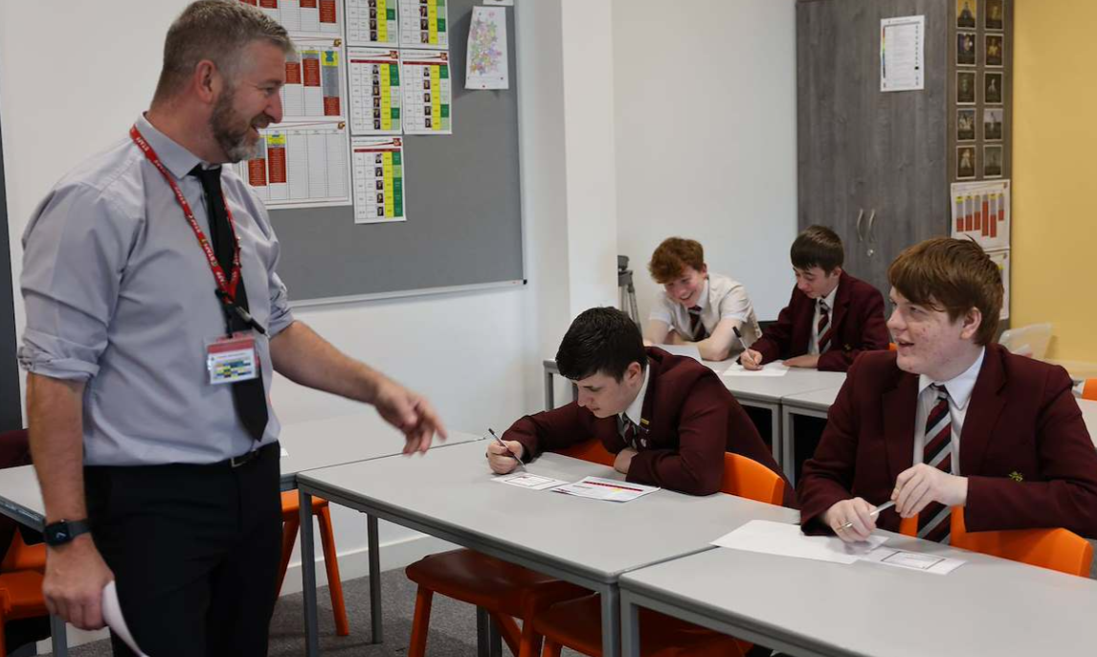

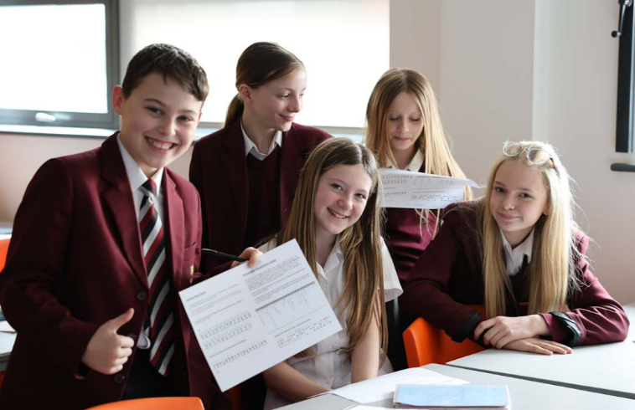
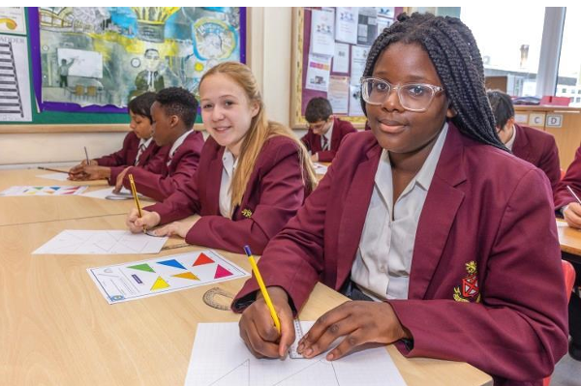

 |  | Autumn |  | Spring |  | Summer
Year 7 | All | Using a Calculator  Order of Operations  Place Value and Rounding  Estimation | Working with Decimals  Directed Number  Algebra intro: Like Terms, Brackets and Substitution | Coordinates  Representing Data  Scatter Graphs  Sequences  Types of Number | Perimeter  Area of 2D Shapes  Working with Fractions | Averages  Time  Angles | Percentages  Consolidation and Problem solving

Students will receive one piece of homework per week via our new online platform “Sparx Maths”. The piece of work will be designed to last around 1 hour. Though the answers are submitted online, students will be expected to complete homework in their books and show all working out. Regular book checks will be performed by their class teacher.

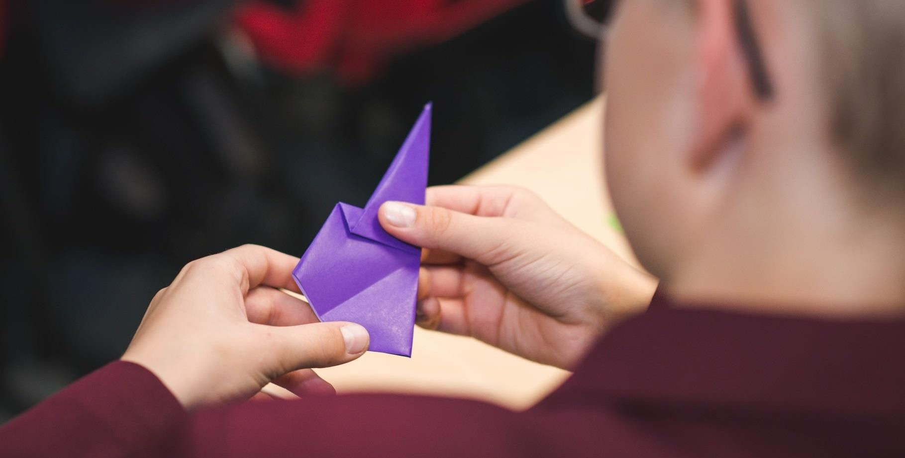

Unit | Lesson Sequencing
1 | 2 Lessons - Using a Calculator  - Know how to reset their calculator.  - Be able to convert answer into decimal form.  - Be able to input fractions, powers, roots, brackets.  - Be able to use the ANS button.  Delete button, Arrow buttons
1 | 2 Lessons - Order of operations (BIDMAS)  - Use the correct priority of operations, including brackets, powers, roots and reciprocals  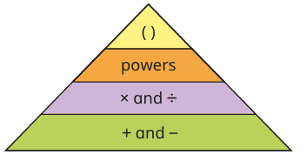
1 | 1 Lesson - Place Value  - Recognise the value of figures in a number using their knowledge of place value.  - Understand the difference between a digit and a number.  - Be able to write numbers as words and vice versa  - Be able to order integers  - Able to place integers numbers on a number line and work out the intervals.  Use =, ≠, <, > to compare integers
1 | 1 Lesson - Ordering Decimals  - Recognise the value of figures in a decimal number using their knowledge of place value.  - Able to place integers numbers on a number line and work out the intervals.  - Use inequality signs to compare decimal numbers  - Be able to order decimal numbers  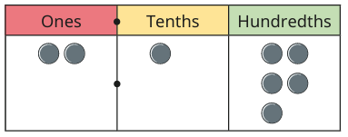
1 | 1 Lesson – Powers of 10  - Be able to multiply by 10, 100, 1000  - Be able to divide by 10, 100, 1000  - Be able to find missing values in calculations involving powers of 10.  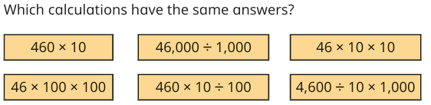  - Recognising numbers as powers of 10 e.g. 1000 = 10³
2 | 1 Lesson – Rounding to Powers of 10  - Be able to round to the nearest 10,100,1000.  - Consider the range of values a number could have been before rounding.  - Use the approximately equal sign and understand why we use this when rounding.  
2 | 1 Lesson – Rounding to the nearest integer  - Be able to round to the nearest integer.  - Consider the range of values a number could have been before rounding.
2 | 1 Lesson – Rounding to Decimal Places  - Be able to round to the nearest tenth, hundredth, thousandth  Consider the range of values a number could have been before rounding.
2 | 3 Lessons - Rounding to Significant Figures  - Able to identify the first significant figure in any number  - Able to recognise how many significant figures a number has  - Able to round to 1, 2 and 3 significant figures  - Consider the range of values a number could have been before rounding.
2 | 2 Lessons – Estimation  - Able to use rounding to one significant figure to estimate the value of calculations.  - Able to do this for worded questions in context.  - Use the approximately equal sign when estimating answers  - Consider whether an answer is an underestimate or an overestimate.
3 | 1 Lesson – Multiplying by 10, 100 and 1000  - Able to multiply and divide integers and decimals by 10, 100 and 1000
3 | 2 Lessons - Addition and subtraction of integers and decimals  - Able to add and subtract whole numbers  - Able to add and subtract decimals  - Practice worded questions in context, where they need to decide for themselves which calculation they need to do.  - Understand the term commutative and that addition is commutative, but subtraction is not.
3 | 2 Lessons – Multiplying and Dividing Integers  - Able to multiply whole numbers.  - Able to divide whole numbers using the bus stop method  - Practice worded questions in context.  - Understand that multiplication is commutative, and division is not.
3 | 3 Lessons – Multiplying and Dividing with Decimals  - Able to multiply a decimal by an integer  - Able to multiply a decimal by a decimal  - Able to divide a decimal by an integer  - Able to use related calculations to solve calculations involving decimals  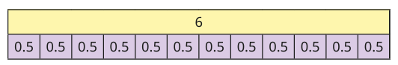
4 | 6 Lessons - Directed Number  - Able to order negative numbers  - Able to add and subtract negative numbers  - Able to multiply and divide negative numbers  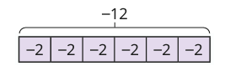  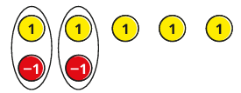  - Able to use a calculator to work with negative numbers
5 | 2 Lessons - Introduction to Algebra  - Understand that a letter can be used to represent an unknown or variable number  - Use correct algebraic notation, e.g. writing 2 × a as 2a, a × b as ab, a × a as a², a ÷ b as $\frac{a}{b}$  - Understand the difference between a term, an expression an equation and an identity (introduce identity sign)  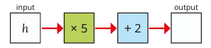
5 | 3 Lessons - Collecting Like Terms  - Identify like and unlike terms within an expression  - Simplify expressions by collecting like terms, including expressions with more than one variable  - Simplify expressions involving the addition and subtraction of negative terms  - Understand that terms can be written in any order without changing the value of the expression
5 | 2 Lessons - Basic Laws of Indices  - Understand index notation and the meaning of a base and power  - Multiply terms with the same base using aᵐ × aⁿ = aᵐ⁺ⁿ  - Divide terms with the same base using aᵐ ÷ aⁿ = aᵐ⁻ⁿ  - Know and apply the facts that a⁰ = 1 and a¹ = a
Unit | Lesson Sequencing
5 | 2 Lessons - Expanding Single Brackets  - Understand that a bracket represents a multiplication of everything inside it  - Expand single brackets with a positive and negative coefficients, e.g. 3(x + 2)  - Expand and simplify expressions involving more than one bracket, e.g. 2(x+3) + 3(x−1)  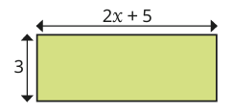
5 | 2 Lessons - Substitution  - Substitute positive integers into simple algebraic expressions  - Substitute negative numbers and decimals into expressions  - Substitute into expressions involving powers, brackets, and more than one variable  - Substitute into formulae used in real-life contexts, focus on using formulae that pupils meet in science lessons.
5 | 5 Lessons - Solving and Forming Equations  - Solve one-step equations using inverse operations  - Solve two-step equations, e.g. 2x + 3 = 11, $\frac{x}{5}$ − 4 = 6  - Check solutions by substituting back into the original equation  - Form and solve simple equations from worded problems and real-life contexts
Unit | Lesson Sequencing
6 | 2 Lessons – Co-Ordinates  - Able to read coordinates in 4-quadrants and write them accurately  - Able to plot coordinates in 4-quadrants  - Able to find the midpoint of two coordinates  - Able to solve problems involving coordinates, such as finding possible vertices of shapes
6 | 2 Lessons - Types of data and questionnaires  - Able to classify data as primary, secondary, qualitative, quantitative, discrete and continuous.  - Pupils should know the features of a good questionnaire and be able to criticise both questions and response boxes of pre-made questionnaires.
6 | 1 Lesson - Tally charts and frequency tables  - Able to create tally charts to collect data and total these to get their frequencies.  - Able to interpret frequency tables and figure out the total from the table.
Unit | Lesson Sequencing
6 | 3 Lessons – Bar Graphs  - know the features of a bar chart and be able to criticise poor drawn bar charts.  - Able to accurately plot axes for the purpose of drawing bar charts.  - Able to draw their own bar charts given a frequency table.  - Able to interpret bar charts.  - Able to draw and interpret dual bar charts.  - Able to interpret composite bar charts.
6 | 4 Lessons – Scatter Diagrams  - Able to plot points on a scatter graph.  - Understand what a scatter graph is used for (showing the relationship between two variables)  - Recognise the different types of correlation.  - Able to describe the relationship between the two variables.  - Able to draw a line of best fit on a scatter graph.  - Able to use a line of best fit to estimate values from a scatter graph and when not to use it (extrapolation)
7 | 3 Lessons - Types of sequence  - Understand the different types of sequence (arithmetic and geometric, Fibonacci)  - Able to continue sequences by spotting patterns  - Able to find missing values in sequences by spotting patterns.  - Able to work with sequences including both numbers and shapes
7 | 3 lessons - Nth term of Linear sequences  - Able to find the nth term of increasing and decreasing linear sequence,  - Able to use the nth term to generate sequences.  - Able to find any number in a sequence using the nth term.  - Able to form equations to determine if a number is in a sequence or not.
8 | 1 Lesson - Types of number  - Understand and be able to recognise different types of number such as square numbers, cube numbers and triangular numbers.  - Pupils will be able to find powers and roots of numbers, using both mental methods and calculator methods.
Unit | Lesson Sequencing
8 | 2 lessons – Factors, Multiples and Primes  - Understand what a factor is and can list the factors of numbers.  - Understand what a multiple is and can list the multiples of numbers.  - Pupils can define what a prime number is and can justify whether a number is prime or not by discussing its factors.
8 | 1 Lesson - Highest common factor  - Find the highest common factor of two or more numbers by comparing lists of factors.  - Answer questions in context involving HCF
8 | 1 Lesson – Lowest Common Multiple  - Find the lowest common multiple of two or more numbers by writing lists  - Answer questions in context involving LCM
8 | 2 Lessons - Product of primes  - Understand the phrase ‘product of primes’ and what it is asking of them.  - Represent numbers as a product of its primes.  - Give their answer in index form.  - Able to use their calculator to express a number as a product of primes.
9 | 1 Lesson – Convert Metric Units of Length  - Able to convert between mm, cm, m and kilometres  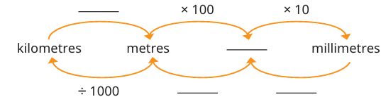  - Able to choose the most appropriate unit for measuring an item.
9 | 1 Lesson – Perimeter of Polygons  - Able to find the perimeter of regular and irregular polygons  - Understand geometric notation to show sides of equal length  - Solve problems in context involving perimeter of polygons.
9 | 1 Lesson – Perimeter of Compound Shapes  - Able to find missing side lengths in compound shapes  - Able to find total perimeter of simple compound shapes  - Solve problems in context involving perimeter of compound shapes.
Unit | Lesson Sequencing
9 | 1 Lesson – Area of Rectangles and Parallelograms  - Able to find the area of quadrilaterals including squares, rectangles and parallelograms.  - Able to find lengths of these shapes, given the area.  - Solve problems in context involving areas of these shapes.  - Pupils know the appropriate units for area calculations.
9 | 1 Lesson – Area of Triangles  - Able to find the area of triangles.  - Able to find lengths of triangles, given the area.  - Solve problems in context involving areas of triangles  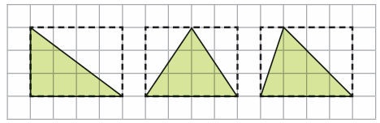
9 | 1 Lesson – Area of a Trapezium  - Able to find the area of trapeziums.  - Able to find lengths of trapeziums, given the area.  - Pupils to solve problems in context involving areas of trapeziums.  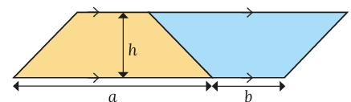
Unit | Lesson Sequencing
9 | 1 Lesson – Area and Perimeter Problem Solving  - Consolidate work done on area and perimeter  - Able to select the correct formula  - Able to solve problems involving a variety of shapes and contexts
10 | 1 Lesson – Fractions as Diagrams and Number lines  - Able to represent quantities as fractions and know the key terms ‘numerator’ and ‘denominator’.  - Able to show fractions on number lines  - Able to represent fractions using diagrams  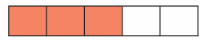  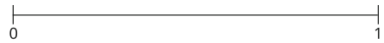
10 | 1 Lesson – Equivalent Fractions  - Know the meaning of the word ‘equivalent’ and be able to represent fractions in a number of ways  - Pupils should be able to scale up fractions to find equivalent fractions and understand that there are an infinite number of equivalent fractions.  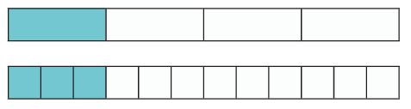
Unit | Lesson Sequencing
10 | 1 Lesson – Simplifying Fractions  - Able to simplify fractions by identifying common factors  - Able to use knowledge of HCF to simplify efficiently  - Able to recognise if a fraction is fully simplified.  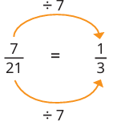  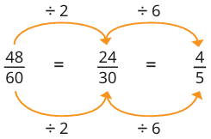
10 | 1 Lesson – Mixed Numbers and Improper Fractions  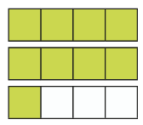  - Able to convert between mixed numbers and improper fractions
Unit | Lesson Sequencing
10 | 1 Lesson – Compare and Order Fractions  - Able to compare fractions using inequalities signs  - Able to put fractions in to ascending size.  - Able to compare fractions using not just a common denominator but also with a common numerator.
10 | 3 Lessons – Adding and Subtracting Fractions  - Able to add and subtract fractions with the same denominator.  - Able to add and subtract fractions with different denominators.  - Able to give answers in their simplest form.  - Able to add and subtract fractions from integers.  - Able to add and subtract mixed numbers.
10 | 2 Lessons – Multiplying Fractions  - Able to multiply a fraction by an integer.  - Able to multiply a fraction by a fraction.  - Able to multiply mixed numbers.  - Able to give answers in their simplest form.
Unit | Lesson Sequencing
10 | 1 Lesson – The Reciprocal  - Understand that the product of a number and its reciprocal is 1.  - Find the reciprocal of integers and fractions.  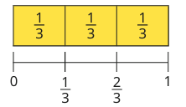
10 | 2 Lessons - Dividing fractions  - Able to divide an integer by a fraction.  - Able to divide a fraction by an integer.  - Able to divide a fraction by a fraction.  - Able to give answers in their simplest form.  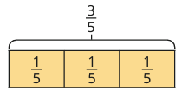
10 | 2 lessons – Fractions of Amounts  - Able to find a fraction of an amount.  - Able to find the original number, given a fraction of it.  - Able to answer questions in context.  - Understand that it is the same process as multiplying a fraction by an integer.
11 | 1 Lesson – Mode  - Consolidate work on data types, quantitative, qualitative, discrete, continuous  - Find the mode from quantitative and qualitative lists of data  - Find the mode from tally charts and frequency tables.  - Discuss the advantages and disadvantages of using the Mode as an average.
11 | 1 Lesson - Mean  - Find the mean from lists of data  - Discuss the advantages and disadvantages of using the mean as an average.  - Discuss outliers and how they effect the Mean  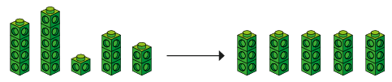
11 | 1 Lesson - Median  - Find the median from lists of data.  - Able to find the midpoint between two numbers.  - Discuss the advantages and disadvantages of using the median as an average.  - Discuss outliers and how they effect the median
Unit | - Lesson Sequencing
11 | 2 Lessons – Solving Problems with Averages and Range  - Working backwards from averages to find missing values.  - Able to solve problems involving a changing mean when a new piece of data is added.  - Able to select the most appropriate average to use for a data set  - Discuss advantages and disadvantages of the mode, mean, median and range.
12 | 1 Lesson - Converting Units of Time  - Able to convert between days, hours, minutes and seconds.
Unit | Lesson Sequencing
12 | 1 Lesson – Convert between the 12 hour clock and 24 hour clock  - Able to convert between 12 hour clock and 24 hour clock
12 | 2 Lessons – Solving Problems with time and timetables  - Able to work out the difference between two times.  - Able to read and interpret timetables  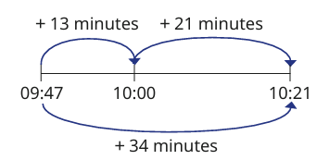
13 | 1 Lesson – Draw and Measure Line Segments and Angles  - Able to accurately draw lines and measure lines using a ruler.  - Know and use 2 letter notation for line segments.  - Able to accurately draw and measure angles.  - Know and use 3 letter notation for angles.  - Know the notation for a right angle.
Unit | Lesson Sequencing
13 | 1 Lesson – Angles around a point  - Know that angles around a point sum to 360º  - Find missing angles around a point.  - Form and solve equations involving angles around a point.  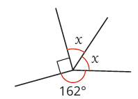
13 | 1 Lesson – Angles on a straight line  - Know that angles on a straight-line sum to 180º  - Find missing angles on a straight line.  - Form and solve equations involving angles on a straight line.
13 | 1 Lesson – Vertically Opposite Angles  - Recognise vertically opposite angles.  - Solve mixed multi step problems involving the three rules encountered so far in this unit.  
Unit | - Lesson Sequencing
13 | 2 Lessons – Angles in Triangles  - Use correct vocabulary and notation to classify triangles.  - Know that angles in a triangle sum to 180º  - Know that each angle in an equilateral triangle will always be 60º.  - Know that base angles in an isosceles triangle are equal and be able to identify the two equal angles.  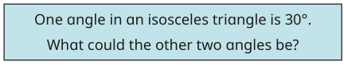  - Form and solve equations from angles in triangles.
13 | 2 Lessons – Angles in Quadrilaterals  - Recognise common quadrilaterals, square, rectangle, parallelogram, kite, rhombus, trapezium.  - Know that interior angles of quadrilateral sum to 360º.
14 | 2 Lessons – Recognising Common Conversions  - Know conversions for tenths, hundredths, half, quarters, eighths, and thousandths.  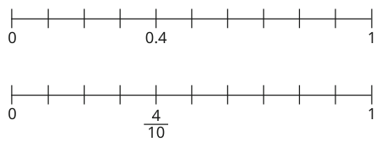
14 | 1 Lesson – Understand Percentages  - Understand what a percentage is.  - Recognise percentages from diagrams.
14 | 3 Lessons – Converting FDP and Ordering  - Convert between fractions and decimals.  - Convert between fractions and percentages.  - Convert between decimals and percentages.  - Compare fractions, decimals and percentages using inequality signs.  - Order a list of Fractions, Decimals and Percentages
Unit | Lesson Sequencing
14 | 2 Lessons – Percentages of amounts (Non-Calculator)  - Able to find percentages of amounts using non-calculator methods.  - Apply this to problems in context.
14 | 3 Lessons – Percentages of amounts (Calculator)  - Understand what a multiplier is.  - Able to calculate percentages of amounts on their calculators using multipliers.  - Know what multipliers to use for percentage increase and decrease.  - Able to answer questions in context.

