Mathematics
Mathematics: working hard together, achieving together, making every lesson count
The Mathematics Team will provide students with exciting, relevant and challenging Mathematics, delivered by dedicated staff.
Students will understand the underlying principles of the mathematics they learn, making links and developing reasoning skills and logical thinking. They will progress towards being independent mathematicians who take ownership of their learning and can identify correct and incorrect work for themselves. Students will have their confidence encouraged and their complacency challenged in order to maximise potential.
To achieve this, staff will design and develop simple and effective systems and interesting and effective teaching ideas and resources to enable classroom delivery and promote mathematics across the school.
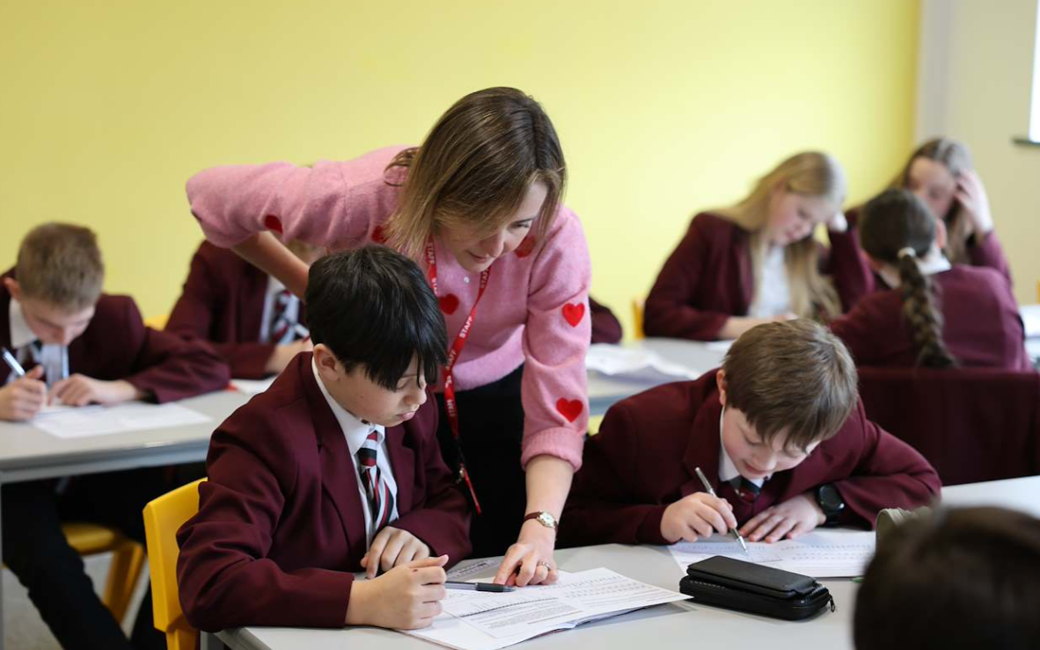

Autumn |  | Spring |  | Summer
Factors, Multiples & Primes. |  |  | Money and Time Formulae Polygons Units of Measure | Speed, Distance and Time Questionnaires and data collection
Indices | Mathematical | FDP | Money and Time Formulae Polygons Units of Measure | Speed, Distance and Time Questionnaires and data collection
Data | Diagrams | Probability | Money and Time Formulae Polygons Units of Measure | Speed, Distance and Time Questionnaires and data collection | Transformations
Analysis | Ratio | Linear | Money and Time Formulae Polygons Units of Measure | Speed, Distance and Time Questionnaires and data collection | Maths in Action
Nets and | Basic Algebra | Graphs | Money and Time Formulae Polygons Units of Measure | Speed, Distance and Time Questionnaires and data collection
Surface | Angles |  | Money and Time Formulae Polygons Units of Measure | Speed, Distance and Time Questionnaires and data collection
Areas |  |  | Money and Time Formulae Polygons Units of Measure | Speed, Distance and Time Questionnaires and data collection

Students will receive one piece of homework per week via our new online platform “Sparx Maths”. The piece of work will be designed to last around 1 hour. Though the answers are submitted online, students will be expected to complete homework in their books and show all working out. Regular book checks will be performed by their class teacher.
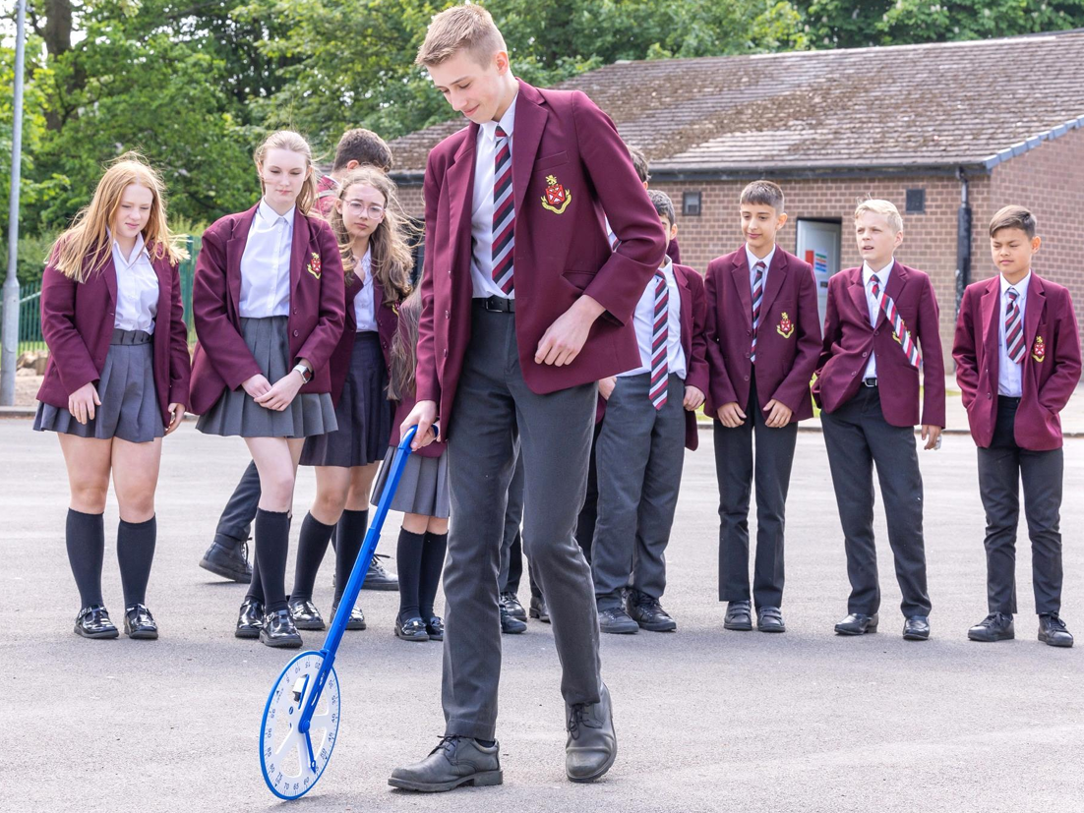

Unit | Duration (WEEKS) | Learning Objectives/Outcomes
Factors, multiples and primes; index notation, squares and roots | 1 | - Products of primes  - LCM and HCF  - Simplifying expressions using index notation  - Squares, cubes, square roots and cube roots
Mathematical Diagrams | 1 | - Mathematical Diagrams  - Mileage charts  - Flow charts and networks
Number Bases and Binary | 1 | - Writing numbers in different bases  - Base 5  - Working in Binary
Rounding and estimating, BIDMAS and use of a calculator. | 2 | - Rounding to given number of decimal places  - Rounding to given number of significant figures  - Estimating calculations by rounding to one SF  - Efficient use of calculator  - Using correct order of operations (including negatives)
Data Analysis | 2 | - Averages and Range  - Pie charts  - Scatter graphs  - Stem and leaf diagrams  - Comparing data  - Estimate of mean from grouped data
Nets and Surface Areas | 2 | - Drawing accurate nets of solids  - Calculating surface area  - Calculating volume of prisms  - Plans and elevations  - Constructing triangles  - Isometric drawings

Ratio | 2 | - Sharing quantities in a given ratio  - Simplifying ratio  - Best buys  - Unitary method  - Currency conversions  - Link with scale drawings and maps
Algebra | 1 | - Expanding brackets  - Simplifying by collecting like terms  - Forming Equations from Geometric problems  - Solving linear equations
Angles | 2 | - Calculating missing angles on parallel lines  - Compass directions with bearings  - Calculations with Bearings  - Constructing Bearings accurately  - Revise angle properties of special triangles and quadrilaterals
Fractions, Decimals and Percentages | 2 | - FDP conversions  - Calculations with percentages (in context)  - Four rules of fractions  - Fractions of / Percentages of quantities  - Increasing and decreasing by given percentage (use of multipliers)
Probability | 1 | - Probability of single events  - Sample space diagrams  - Probability of successive events  - Listing outcomes
Linear Graphs | 1 | - Plotting linear graphs from table of values  - Plotting linear graphs using own axes  - Recognising parallel lines  - Investigation into gradient and y-intercepts of linear graphs

Money and Time | 2 | - Looking into wages/bills  - Expenses involved in running a home  - SMSC comparing countries
Formulae | 1 | - Substituting values into given formulae (including negatives)  - Rearranging Formulae
Polygons | 2 | - Interior angle sums of polygons  - Exterior angles of Polygons  - Regular Polygons  - Combined polygons – calculating missing angles  - Naming all polygons up to 10 sided
Units Estimating capacity, length, mass and conversions | 1 | - Conversions between units  - Metric and imperial units  - Estimating capacity, length  - Density, mass and volume  - Converting between units, metric and imperial.
Speed, Distance and Time | 1 | - Calculations involving speed, distance and time  - Interpreting distance time graphs  - Constructing distance time graphs  - Looking into other travel graphs
Questionnaires and data collection | 1 | - Forming questions to be used in questionnaires  - Being critical of bad questionnaires.  - Discuss biased and leading questions  - Designing data collection sheets
Transformations | 1 | - Carrying out Rotations, Reflections, Translations  - Describing Rotations, Reflections and Translations  - Enlargements  - Link enlargements with similarity.  - Combined transformations  - Inc. centre of enlargements for more able

