Mathematics
Mathematics: working hard together, achieving together, making every lesson count
The Mathematics Team will provide students with exciting, relevant and challenging Mathematics, delivered by dedicated staff. Students will understand the underlying principles of the mathematics they learn, making links and developing reasoning skills and logical thinking.
They will progress towards being independent mathematicians who take ownership of their learning and can identify correct and incorrect work for themselves. Students will have their confidence encouraged and their complacency challenged in order to maximise potential. To achieve this, staff will design and develop simple and effective systems and interesting and effective teaching ideas and resources to enable classroom delivery and promote mathematics across the school.

Autumn |  | Spring |  | Summer
Data Handling, data collection, representing & analysing data.  Formulae & Expressions | Factoring Expressions,  Solving Equations, including Numerical Methods  Fractions, Decimals & Percentages  Index Laws | Inverse operations & Accuracy.  Angles & Triangles  Polygons, Nets, plans & elevations  Ratio | Factors, Multiples, Primes (HCF/LCM)  Probability | Perimeter, Area & Volume, including parts of a circle  Pythagoras and Basic Trigonometry | Changing the subject of a formula  Linear Graphs

Students will receive one piece of homework per week via our new online platform “Sparx Maths”. The piece of work will be designed to last around 1 hour. Though the answers are submitted online, students will be expected to complete homework in their books and show all working out. Regular book checks will be performed by their class teacher.

In Year 9 your child will continue their studies on either the Foundation or Higher pathway. Again, there is a flexible approach should the need arise for a change in pathway. In the year 9 programme of study, both pathways have been designed to complement each other should a change be required.

Higher
Unit | Duration (WEEKS) | Learning Objectives/Outcomes
KjdData Handling | 5 | - Classifying data  - Collecting Data  - Analysing Data  - Interpreting Data  - Sampling
The four operations, cubes, cube roots and squares | 1 | - Calculations using the correct order of operations  - Recall integer squares from 1x1 to 15x15 and their corresponding square roots.  - Recall the Cubes of 2,3 4, 5 and 10 and their corresponding cube roots.  - Solve problems involving the four operations
Expressions, Equations & Formulae | 4 | - Forming Expressions  - Simplifying Expressions  - Expanding Brackets  - Factorising Expressions  - Solving Equations including Numerical Methods  - Substitution into Formulae
Fractions, Decimals & Percentages | 2 | - FDP equivalence  - Fours rules of fractions  - Ordering rational numbers  - Calculations involving Percentages  - Percentage Change  - Expressing one quantity as a percentage of another quantity.
Index Laws | 2 | - Simplifying Expressions using the rules of indices  - Calculations involving the rules of indices
Percentages; Compound interest, Depreciation & Reverse problems | 1 | - Compound Interest  - Depreciation  - Reverse Percentages
Inverse Operations & Accuracy | 1 | - Understand ‘reciprocal’ as multiplicative inverse, knowing that any non-zero number multiplied by its reciprocal is 1  - Use given calculations to find the answers to other calculations.  - Rounding values to a given number of decimals places and significant figures.  - Estimate the answers to calculations by rounding to one significant figure.
Angles & Triangles | 2 | - Classify Triangles  - Calculations of unknown angles in or around triangles  - Calculations of angles on parallel lines  - Angle reasoning  - Problem solving involving angles
Polygons | 1 | - Classifying Polygons  - Calculating interior angles with polygons  - Calculating exterior angles with polygons  - Calculating unknown angles within problems involving conjoined polygons  - Understand why some polygons tessellate.
Net, Plans and Elevations | 1 | - Draw accurate nets of given solids  - Recognise solids from given nets  - Draw and interpret accurate diagrams involving plans and elevations  - Understand and recognize 3D coordinates
Ratio | 2 | - Share quantities in a given ratio  - Simplify ratio including 1:n and n:1  - Solve problems involving more than one ratio  - Solve problems involving ratio and algebra  - Solve problems involving ratio and geometry
Factors, multiples & Primes | 1 | - Express values as a product of their prime factors  - Solve problems involving HCF and LCM  - Use products of primes to calculate HCF and LCM
Probability | 3 | - Calculating probability  - Experimental probability (Relative Frequency)  - Sample space diagrams  - Independent and dependent events  - Probability Tree Diagrams
Perimeter, Area and Volume | 3 | - Area and Perimeter of 2D Shapes  - Volume of solids  - Calculating areas of sectors  - Calculating Arc lengths
Pythagoras & Basic Trigonometry | 3 | - Using Pythagoras to calculate unknown sides of right-angled triangles  - Using Trigonometry to calculate unknown sides of right-angled triangles  - Using Trigonometry to calculate unknown angles in right-angled triangles  - Problems involving Pythagoras & Trigonometry
Changing the subject of formulae | 1 | - Rearrange given formulae  - Rearrange formulae by a given subject, that appears more than once.
Linear Graphs | 2 | - Plotting linear graphs from tables of values  - Recognise Gradient and y-intercept.  - Plotting linear graphs using the gradient and intercept  - Calculating the equations of parallel and perpendicular lines  - Calculating the equations of lines given two points.

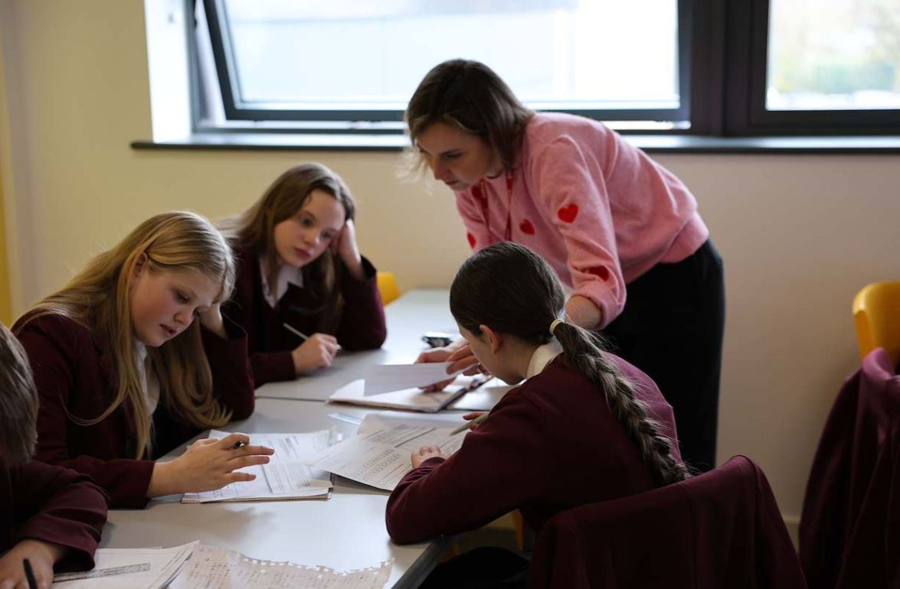

Foundation
Unit | Duration (WEEKS) | Learning Objectives/Outcomes
KjdData Handling | 5 | - Classifying data  - Collecting Data  - Analysing Data  - Interpreting Data  - Sampling
The four operations, cubes, cube roots and squares | 1 | - Calculations using the correct order of operations  - Recall integer squares from 1x1 to 15x15 and their corresponding square roots.  - Recall the Cubes of 2,3 4, 5 and 10 and their corresponding cube roots.  - Solve problems involving the four operations
Expressions, Equations & Formulae | 4 | - Forming Expressions  - Simplifying Expressions  - Expanding Brackets  - Factorising Expressions  - Solving Equations including Numerical Methods  - Substitution into Formulae
Fractions, Decimals & Percentages | 2 | - FDP equivalence  - Fours rules of fractions  - Ordering rational numbers  - Calculations involving Percentages  - Percentage Change  - Expressing one quantity as a percentage of another quantity.
Index Laws | 2 | - Simplifying Expressions using the rules of indices  - Calculations involving the rules of indices
Percentages; Simple Interest & Compound Interest | 1 | - Simple Interest  - Compound Interest
Inverse Operations & Accuracy | 1 | - Understand ‘reciprocal’ as multiplicative inverse, knowing that any non-zero number multiplied by its reciprocal is 1  - Use given calculations to find the answers to other calculations.  - Rounding values to a given number of decimals places and significant figures.  - Estimate the answers to calculations by rounding to one significant figure.
Angles & Triangles | 2 | - Classify Triangles  - Calculations of unknown angles in or around triangles  - Calculations of angles on parallel lines  - Angle reasoning  - Problem solving involving angles
Polygons | 1 | - Classifying Polygons  - Calculating interior angles with polygons  - Calculating exterior angles with polygons  - Calculating unknown angles within problems involving conjoined polygons  - Understand why some polygons tessellate.
Net, Plans and Elevations | 1 | - Draw accurate nets of given solids  - Recognise solids from given nets  - Draw and interpret accurate diagrams involving plans and elevations
Ratio | 2 | - Share quantities in a given ratio  - Simplify ratio including 1:n and n:1  - Solve problems involving ratio and algebra  - Solve problems involving ratio and geometry
Factors, multiples & Primes | 1 | - Express values as a product of their prime factors  - Solve problems involving HCF and LCM  - Use products of primes to calculate HCF and LCM
Probability | 3 | - Calculating probability  - Experimental probability (Relative Frequency)  - Sample space diagrams  - Independent and dependent events  - Probability Tree Diagrams
Perimeter, Area and Volume | 3 | - Area and Perimeter of 2D Shapes  - Volume of Prisms  - Calculating areas of sectors  - Calculating Arc lengths
Handling Data | 2 | - Scatter Graphs  - Pie Charts  - Pictograms  - Stem and Leaf Diagrams  - Problems involving averages.
Changing the subject of formulae | 1 | - Rearrange given formulae
Linear Graphs | 2 | - Plotting linear graphs from tables of values  - Recognise Gradient and y-intercept.  - Plotting linear graphs using the gradient and intercept  - Recognising the equations of parallel lines

